5th ANNUAL
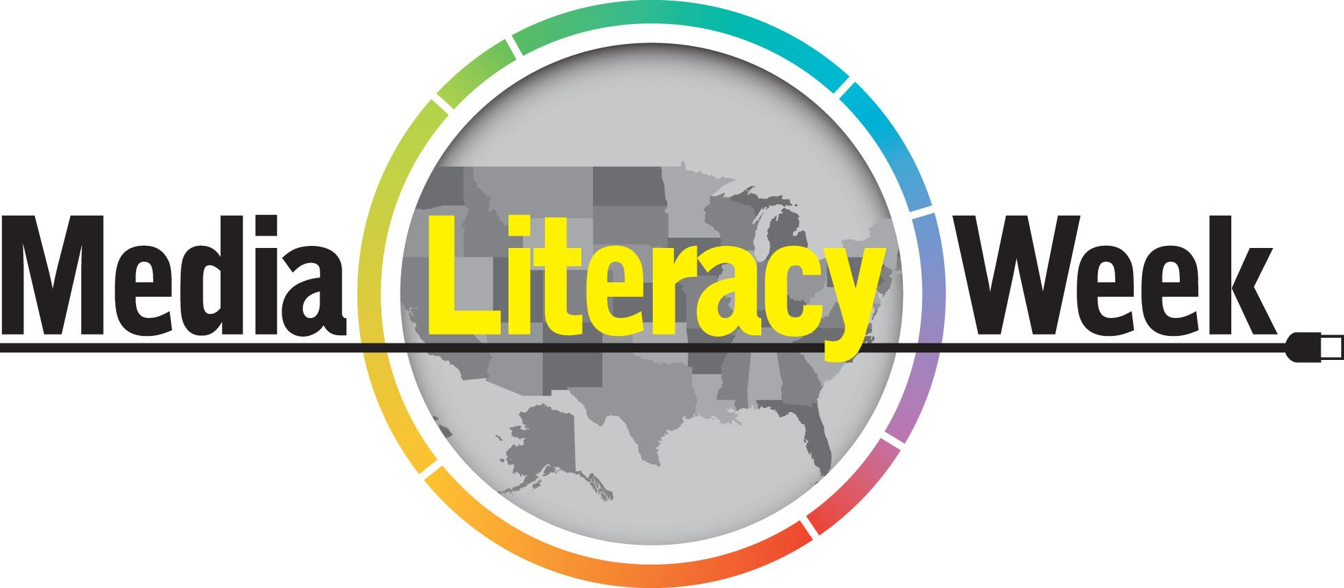

OCTOBER 21 – 25, 2019

Hosted By:
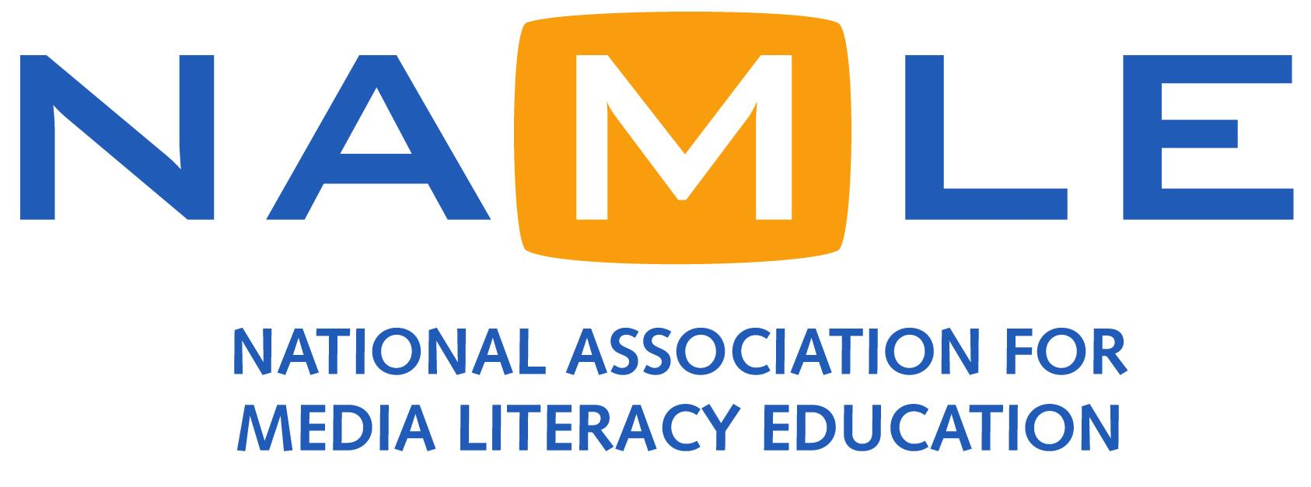

TABLE OF CONTENTS

EVENT OVERVIEW
The Purpose
Who is doing it--and how you can too
Why it matters
What you can do

IMPORTANT INFORMATION
MLW Leadership
Important Links
Follow NAMLE online

SOCIAL MEDIA MESSAGING
Media Literacy Week Social Media Graphics
Sample Facebook Posts
Sample Twitter Posts

FREQUENTLY ASKED QUESTIONS

CORE MEDIA LITERACY MESSAGES

IMPORTANT INFORMATION FOR PARTNERS

ABOUT
About Media Literacy Week U.S.
About NAMLE

EVENT OVERVIEW
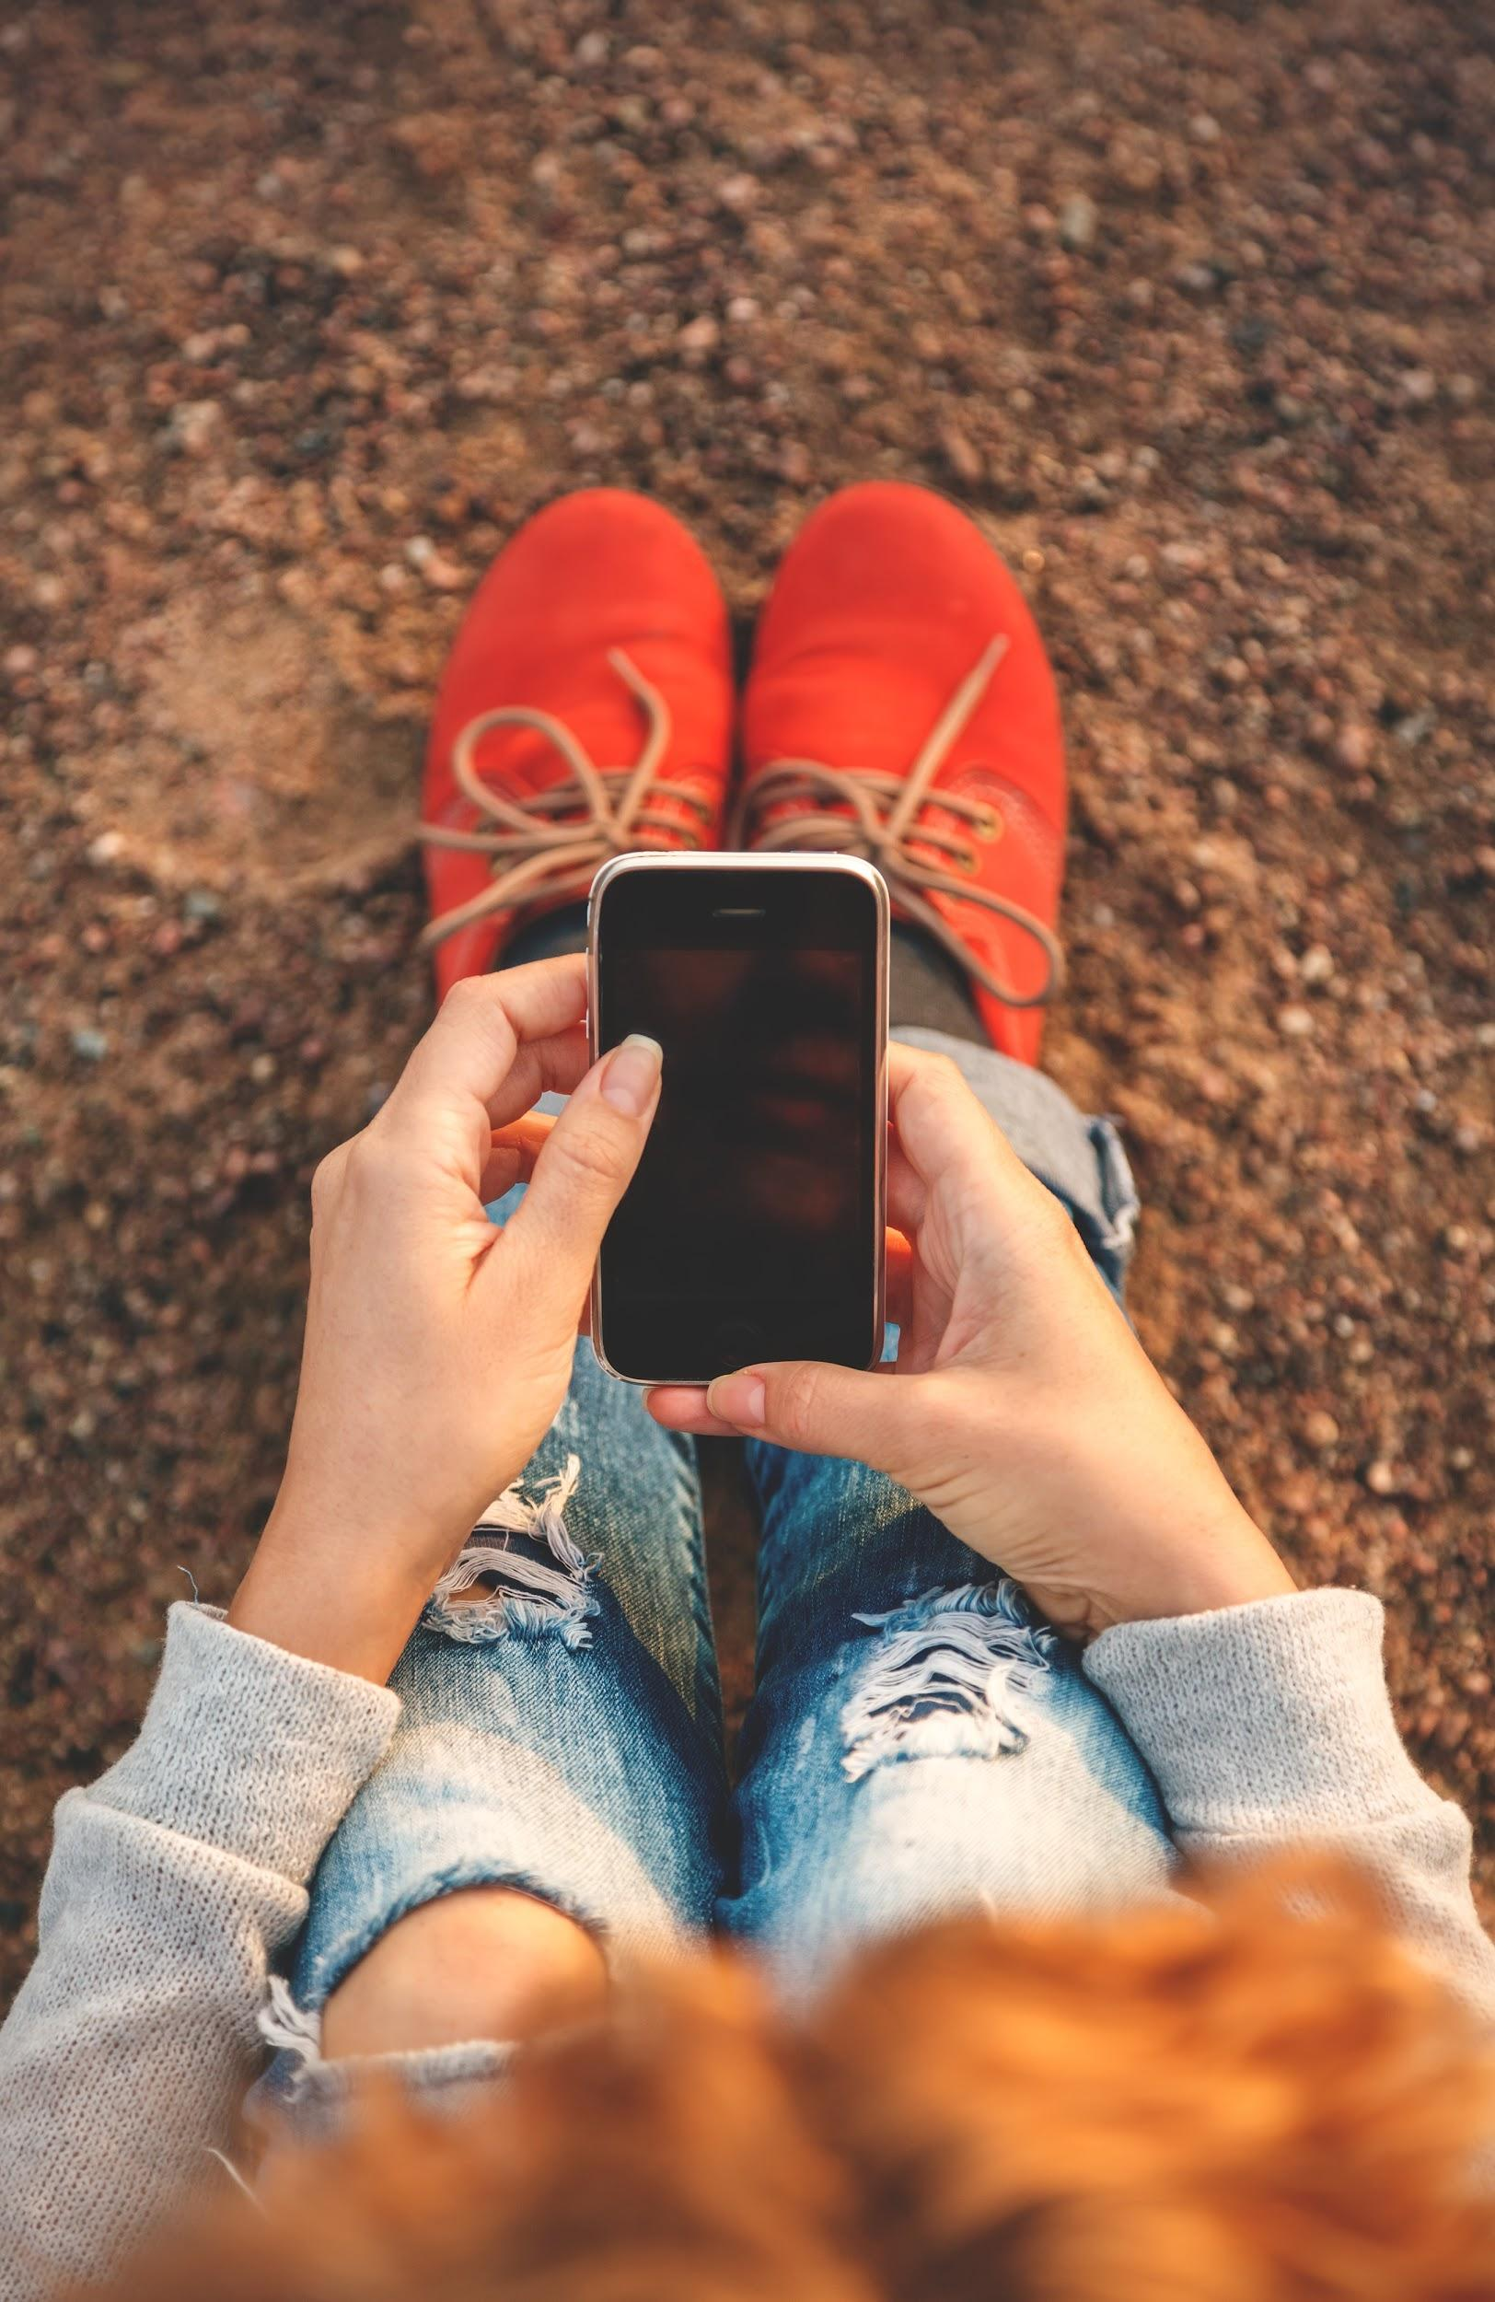
WHAT IS U.S. MEDIA LITERACY WEEK?
The 5th annual Media Literacy Week (https://medialiteracyweek.us) in the United States is being held October 21-25, 2019. The mission of Media Literacy Week is to highlight the power of media literacy and its essential role in education today. Hosted by the National Association for Media Literacy Education (NAMLE), U.S. Media Literacy Week brings together hundreds of partners for events and activities around the county. This important initiative has the support of a large group of sponsors, partnering organizations and media literacy experts from all over the country who are dedicated and passionate about media literacy education.

THE PURPOSE
The purpose of Media Literacy Week is to demonstrate the importance and power of media literacy education and its essential role in education today.

WHO IS DOING IT AND HOW YOU CAN TOO
All over the country, partners are organizing events and teachers are planning media literacy lessons in an awareness week coordinated by NAMLE. Organizations or educators wishing to participate should visit https://medialiteracyweek.us and/or contact us at medialiteracyweek@namle.net.

WHY IT MATTERS
Media literacy skills are vital to living and learning in the 21st century. As the speed and quantity of information grow exponentially, we need to critically think about the role media play in our lives, our society, and our world. At a moment when families, advocates and public officials are rethinking the way schools operate, it is important for media literacy to be part of that discussion if learning is to grow and evolve.
WHAT YOU CAN DO

PLAN AN EVENT OR ACTIVITY
Need help formulating ideas for events or activities with you students or community? Try one of these activities:
- Host an event during Media Literacy Week!
- Hold a lecture, debate, or colloquium at a college or university.
- Host a youth workshop.
- Support media literacy legislation.
- Promote Media Literacy Week on social media.
- Gather teachers for a professional development workshop.
- Organize a film screening and panel discussion.
- Create a film festival of youth media projects developed in your classroom or community.
- Organize a tour of a local television or radio station for youth or community members.
- Host a webinar about news literacy.
- Partner with a local maker space and explore new forms of reading and writing with emergent technology.

CHECK OUT OUR RESOURCES
We’ve also curated resources for a variety of audiences which includes both samples of past events as well as basic media literacy resources to get you started. You can find more on the Media Literacy Week website for:
- Elementary school
- Middle school
- High school
- Post-secondary
- Community organizations

MLW LEADERSHIP TEAM

LEADERSHIP
Michelle Ciulla Lipkin, Executive Director
Donnell Probst, Associate Director
Cynthia Lieberman, Social Media
Yamil Casas, Partner Coordinator

CONTACT
Web: www.medialitearcyweek.us
Email: medialiteracyweek@namle.net

LINKS + DOWNLOADS

MLW LOGOS
https://www.dropbox.com/sh/ggnazcgkohdjog8/AADcGXFjoDIPp-z7YbwE6Z1Va?dl=0

MLW MEMES
https://www.dropbox.com/sh/5ege2qj1gexth6a/AAA-47NR0E07maWGQmuTKzYTa?dl=0

MLW SOCIAL MEDIA GRAPHICS
https://www.dropbox.com/sh/f1n39xpqexbzcng/AADkBVJeq-mtOCIhkBgqyxxka?dl=0

SOCIAL MEDIA MESSAGING

USE #MediaLitWk on all MLW posts and tweets!

SAMPLE FACEBOOK POSTS
NAMLE is hosting Media Literacy Week USA! Join us in celebrating 21st-century skills learners and educators by attending an event or becoming a partner today: https://medialiteracyweek.us/become-a-partner

This year, celebrate media literacy with Media Literacy Week from October 21-25! Join organizations nationwide and partner with us in this historic event: https://medialiteracyweek.us/become-a-partner

Ready to share your work on a national stage? Orgs and educators from California to Rhode Island are participating in U.S. Media Literacy Week! Learn more about partnering here: https://medialiteracyweek.us/become-a-partner

For use after 10/19 only:
Media Literacy Week USA kicks off in just a few days! Check out our calendar of nationwide events: https://medialiteracyweek.us/home/calendar

SAMPLE TWITTER POSTS
@MediaLiteracyEd is hosting #MediaLitWk Oct 21-25! Attend/host an online event: https://medialiteracyweek.us/

USA National #MediaLitWk kicks off October 21st! Partner w/ us, find an event & #medialiteracy resources here: https://medialiteracyweek.us/

Celebrate #medialiteracy #education during #MediaLitWk! Events, partners, resources, more! https://medialiteracyweek.us/

For use after 10/19 only: Just a few days till #MediaLitWk! Check out the Global MIL Week events map to see what is happening near you:

Visit #MediaLitWk website for info on how to participate in US #MediaLitWk Week, Oct 21-25 https://medialiteracyweek.us/

@MediaLiteracyEd is hosting #MediaLitWk Oct 21-25! Attend/host an online event: https://medialiteracyweek.us/home/calendar-of-events/

SAMPLE TWITTER POSTS (PARTNERS)
Join us as partners with @MediaLiteracyEd for #MediaLitWk in the US! https://medialiteracyweek.us/home/partners/

Proud Partner of #MediaLitWk USA hosted by @MediaLiteracyEd: 5th Annual Media Literacy Week in the US! --> https://medialiteracyweek.us/home/partners/

Wow! Hundreds of partners joining in for the 5th Annual #MediaLitWk USA! You can be the one too: https://medialiteracyweek.us/home/partners/

Proud Partner of 5th Annual National Media Literacy Week October 21-25! Join us! #MediaLitWk https://medialiteracyweek.us/home/partners/

STILL TIME to become a Partner! Join 150+ @MediaLiteracyEd partners for #MediaLitWk! Add your own events, webinars, and more. https://medialiteracyweek.us

Join 150+ #MediaLitWk partners, including [insert your handle] Sign up today! https://medialiteracyweek.us/currentpartners/

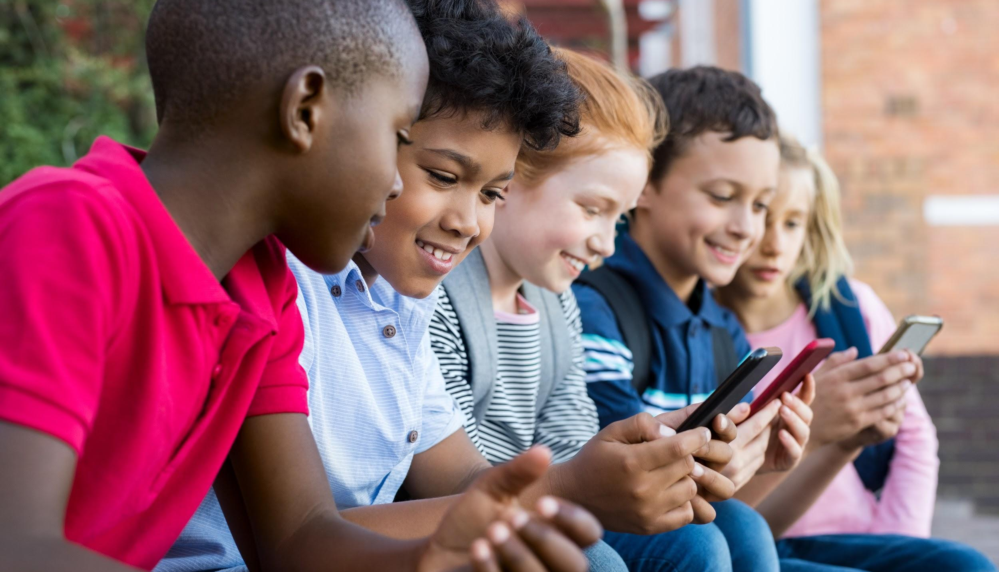
FREQUENTLY ASKED QUESTIONS

Does it cost to be a partner for media literacy week?
No. There is no cost involved. Partners simply commit to coordinating an event involving media literacy education to take place during Media Literacy Week. Partners are asked to join in the promotion of Media Literacy Week activities on their own website and through their own social media channels in weeks prior to and during Media Literacy Week.

Do you have to be associated with an organization to join in on the efforts?
No. Individual educators from PK-16 and beyond can decide to be a part of Media Literacy Week. Each year, teachers, librarians, specialists, and other practitioners are planning events and activities for students to engage in during Media Literacy Week. Once you have planned an event or activity you can register your event here. If you’d like to sign up your organization or institution as a Media Literacy Week Partner, you can do so here.

How are the U.S. Media Literacy Week plans related to the Canadian Media Literacy Week?
The U.S. effort was inspired by the work of our Canadian neighbors. NAMLE has collaborated with Media Smarts (http://mediasmarts.ca) one of the lead partners for the Canadian Media Literacy Week (http://www.medialiteracyweek.ca) for several years during Media Literacy Week. NAMLE and Media Smarts work closely each year to support the efforts across North America. We are grateful for the guidance and support we have received from Media Smarts. Media Smarts is also an organizational partner of NAMLE.

Do you have to be a member of NAMLE to be a partner in Media Literacy Week?
No. Anyone can get involved. However, we hope you do consider becoming a NAMLE member so that you can stay engaged with media literacy education throughout the year – plus, membership is free for individuals! Please contact us at namle@namle.net if you want more information about membership. Join today https://namle.net/membership/membership-benefits-2/.

CORE MEDIA LITERACY MESSAGES

Today’s world is saturated by media messages.
- Youth spend an average of 10 hours and forty-five minutes with media per day. (https://www.kff.org/other/event/generation-m2-media-in-the-lives-of/)
- Food and beverage marketers spend $150 million every year to reach K-12 youth directly in schools. (http://www.ruddrootsparents.org/food-marketing-in-schools/learn-more)
- 92% of youth go online daily. (http://www.pewinternet.org/2015/04/09/teens-social-media-technology-2015/)
- Half of younger adults live in a household with three or more smartphones. More than nine-in- ten 18- to 29-year-olds (96%) say they live in a household with at least one smartphone, and 51% of young adults say their home contains three or more such devices. (http://www.pewresearch.org/fact-tank/2017/06/28/10-facts-about-smartphones/)
- Media promote the notion that girls should be concerned about their appearance and should treat their bodies as sexual objects for others’ consumption. (https://www.commonsensemedia.org/sites/default/files/uploads/pdfs/2017_commonsense_watchinggender_executivesummary_0620_1.pdf)

Despite the amount of time youth spend with media, studies indicate they lack some basic media literacy skills.
- In one recent global study, US millennials ranked last or in the bottom 50% out of 22 countries for numeracy, literacy and problem-solving skills. (http://www.ets.org/s/research/29836/rsc/pdf/millennials_handout_print.pdf)
- Consumption of certain media content by youth has been linked to issues such as self-esteem and body image (http://cmch.tv/parents/body-image/) suggesting that young people lack the skills to be critical of media.

Media literacy is the ability to access, evaluate, analyze, act, communicate and create using all forms of media.

CORE MEDIA LITERACY MESSAGES (cont’d)

Media Literacy is a crucial life skill in the 21st century.
Virtually all careers today require some level of critical thinking about media and media messages, as well as the ability to produce and work with a variety of media and information.

Media Literacy should be an essential part of education today.
Low-income schools and communities in particular often lack the resources needed to adequately prepare them to create and criticize media and technology.

Media Literacy empowers people to be both critical thinkers and creative producers.

Media Literacy Week USA is a celebration of the efforts by educators and organizers nationwide to prepare youth to live, learn and thrive with media.

ABOUT U.S. MEDIA LITERACY WEEK

Media Literacy Week is designed to bring attention and visibility to media literacy education in the United States. Inspired by Canada's Media Literacy Week now in its 13th year, the National Association for Media Literacy Education’s Media Literacy Week is now in its fifth year in the U.S. For more info visit medialiteracyweek.us or contact medialiteracyweek@namle.net.

ABOUT NAMLE

The National Association for Media Literacy Education (NAMLE) is a professional association for educators, academics, activists, and students with a passion for understanding how the media we use and create affect our lives and the lives of others in our communities and in the world. The NAMLE vision is to help individuals of all ages develop the habits of inquiry and skills of expression that they need to be critical thinkers, effective communicators and active citizens in today's world. For more information, visit namle.net.

